Introduction to C#

|  |  |
| --- | --- |
| **Assessment Task Number:** Part 1 – Debugging Problems | |
| **Unit Code(s):** | **Unit Title(s):** |
| ICTPRG430 | Apply introductory object-oriented language skills |
| ICTPRG440 | Apply introductory programming skills in different languages |
| **Instructions to Learners:** | |

Complete the following C# programming tasks on debugging.

**Task 1:**

Capture a screenshot of Visual Studio running in debug mode.

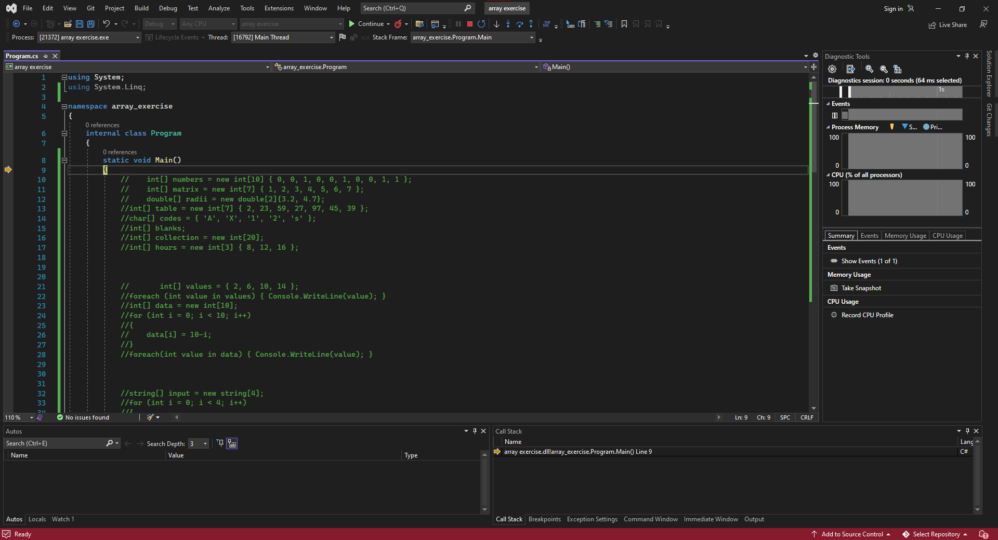

**Task 2:**

Capture a screenshot of 3 different compiler errors.

Write a brief description (1 or 2 sentences) of what each error means.

|  |  |  |
| --- | --- | --- |
|  |  |  |
| Error code cs0029: Cannot implicitly convert type ‘string’ to ‘bool’. This was caused by using an incorrect statement inside of an if statement. This could be fixed by including an accepted statement, such as using (operator == “*”) which will compare the variable and the input. | Error code cs1002: “;” expected. This was caused by not using a semicolon at the end of a line of code. This can be simply fixed by placing a semicolon at the end of the line. | Error code cs1525: Invalid expression term ‘==’. This was caused by using an expression which compares two terms while declaring the value of a variable. This can be fixed by using the correct expression “=”. |

**Task 3:**

List at least one website that you can use as a reference when learning C#.

<https://www.w3schools.com/cs/index.php>

https://stackoverflow.com/questions/tagged/c%23

**Task 4:**

Capture one or more screenshots showing:

* A breakpoint
* 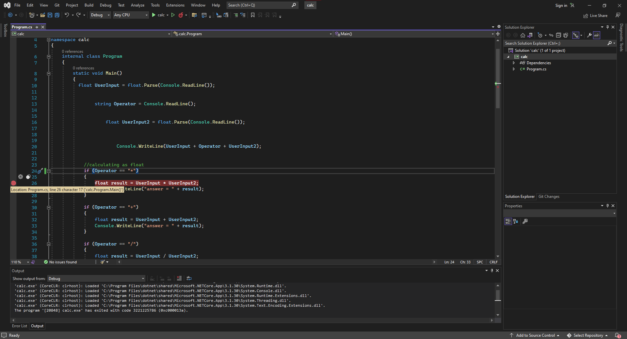
* A variable watch, and the callstack
* 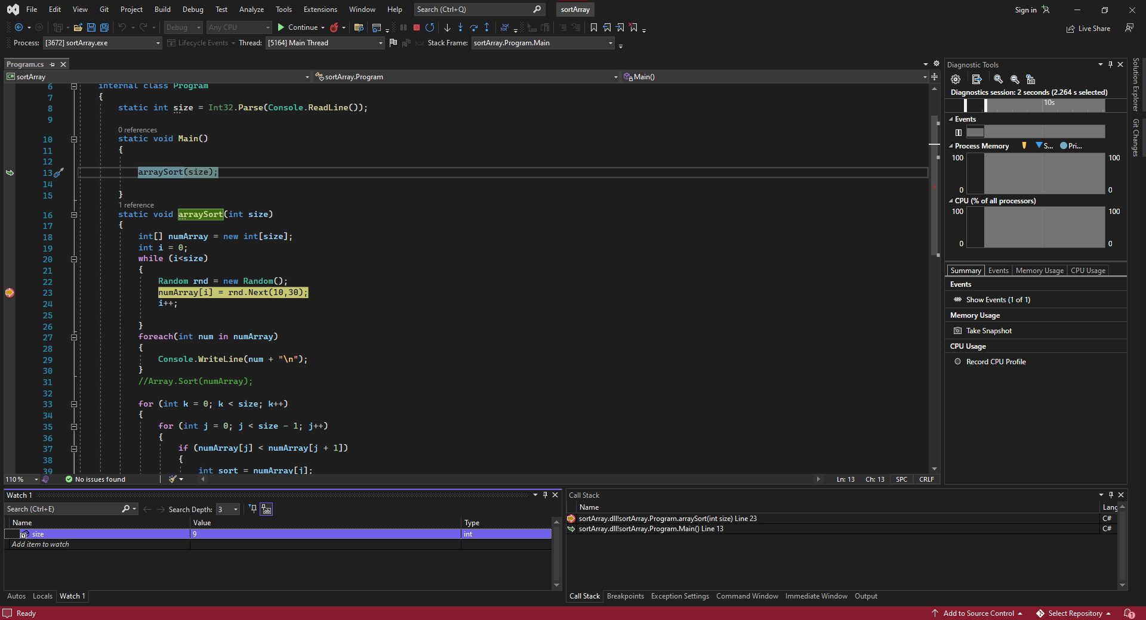

These tasks can be completed during the completion of any of the other assessment tasks or programs created for this subject.

Answer all questions and insert all screenshots into a single document in MS Word or PDF format.

|  |  |  |
| --- | --- | --- |
| **Task** | | **Evidence Criteria** |
| 1. | Run in Debug Mode | Capture a screenshot showing Visual Studio running in debug mode. |
| 2. | Describe Compiler Errors | Capture one or more screenshots showing different compiler errors.  Describe what each error means. |
| 3. | List Sources of Information | List at least one website that provides material to aid you in understanding the C# language. |
| 4. | Identify Debugging Features | Upload a screenshot showing   1. A breakpoint 2. A variable watch, and 3. The callstack |
| **Submission Requirements:** | | |
| You will need to submit the following:   * A single document containing all your screenshots and answers, in MS Word or PDF format   Upload your document to the assessment submission page on Canvas. | | |